ALIHUSAIN CHAROLIA (30399895), ARSH CHAWLA (30403496), HEMANG DESAI (30401951), UMER NAZIR (30395853), HAMMAD JAWAID (30403390)

TravEl Care

Project Handbook

SA Tourism Booster





# Revision

|  |  |  |  |
| --- | --- | --- | --- |
| Version Number | Date approved | Approved by | Description |
| 3.0 | 08/10/2022 | Alihusain Charolia | Project Vision Statement, High-Level Roadmap for the project, Team Charter, and Technical documentation |
|  |  |  |  |

# Preface

*The main purpose of this document is to plan and organise project SA Tourism Booster and document project team decisions. The document clearly states the project vision, introduces the project, project deliverables and objectives. This is the third draft of the document that focuses on the project vision statement, high-level roadmap for the project, documenting the organization and processes of the project team and documenting the non-functional requirements of the project. The document also provides information on tools and technologies being used for project development.* *Project team members are the main users of this handbook. Project Team will be progressively adding to and improving the document as team knows more about the project. Other from team members this document will be used by mentor and the client.*

Table of Contents

Revision 1

Preface 1

List of Figures 3

List of Tables 3

Vision Statement 5

System Capabilities 5

Business benefits 5

1. Introduction 5

1.1 Project Overview 5

1.2 Project Deliverables 7

1.3 Evolution of the Handbook 8

1.4 Reference Materials 8

1.5 Definitions and Acronyms 9

2. Organization 11

2.1 Process Model 11

2.2 Organizational Structure 19

2.3 Organization Boundaries and Interfaces 21

2.4 Project Responsibilities 22

3. Managerial Process 23

3.1 Management Objectives and Priorities 23

3.2 Assumptions, Dependencies, and Constraints 24

4. Technical Process 26

4.1 Methods, Tools, and Techniques 26

4.2 Software Documentation 30

5. High level Project Plan 31

6. Non-functional Requirements 39

6.1 Platform 39

6.2 Communication 40

6.3 Performance 40

6.4 Security and Privacy 40

6.5 Audience, Usability and Accessibility 41

6.6 Reliability 41

6.7 Modifiability 41

6.8 Economic 42

6.9 Legal 42

6.10 Standards 42

7. Software and Systems Architecture 42

7.1 Architecture objectives 42

7.2 High-level architecture 43

7.3 System context 45

7.4 User Interface / Interaction Design 45

7.5 Data model and software design 50

7.6 Assumptions 51

7.7 External Dependencies 52

Additional Components 52

Index 52

Appendices 52

# List of Figures

Figure 1 Six stages for Agile Scrum Practices 14

Figure 2 Team Organisation 21

Figure 3 Scrum Framework 28

Figure 4 WBS 39

Figure 5 Three-Tier Architecture 43

Figure 6 System Context Diagram 45

Figure 7 Initial User Flow 46

Figure 8 SiteMap 51

# List of Tables

Table 1 Resources Required 7

Table 2 Assessment Tasks 8

Table 3 Team Member Responsibility and Outcome 12

Table 4 Process Model of Scrum six stages 13

Table 5 Sprint 1 User Stories and Tasks 17

Table 6 Sprint 2 User Stories and Tasks 19

Table 7 Scrum Roles, Allocated Members and Responsibilities 20

Table 8 RACI Matrix 23

Table 9 Assumptions 25

Table 10 Dependencies 25

Table 11 Constraints 26

Table 12 Tools 27

Table 13 Communication Tools 29

Table 14 Diagrams Used 30

Table 15 Documentation Type 30

Table 16 Documentation Testing Strategy 31

# Vision Statement

SA Tourism Booster aims to boost up the local tourism industry, which has been badly affected by Covid19, war eruption in Ukraine and many other disruptions. With this web platform the local business owners can easily advertise their business on website, by providing the information of their business and offers. This way those local businesses that are hidden and unknown to many people can be explored. Tourists on the other hand can benefit out of information provided and explore multiple places located in South Australia with ease and affordable prices. Apart from this, this platform will also help to build a stronger community of local businesses to interact with each other smoothly and offer join deals. The website aims to remove the intermediary and letting business owners to advertise their services under one platform.

## System Capabilities

The website is designed in a way that it can run on both mobile and desktops. A dedicated and secure server is allocated to store the data provided by businesses. Business owners will be able to advertise their individual business services on the web platform, however if they wish to out traffic to their own social media links, our website will be able to route tourists to their respective social media pages.

## Business benefits

Business benefits will include the dedicated platform for tourism where business owners with paid subscription can display their business and earn through traffic on them. It can be used for digital marketing of sponsors and partnered organizations. Increased tourism will benefit local businesses that are adversely impacted and will overall improve economy of the state.

# Introduction

## 1.1 Project Overview

The project will be based on a web application that can be used by business owners and tourists to establish an economic relationship between them. It allows local business to grow-up by maximizing marketing of their services, improving efficiency of the business from the feedback, gaining valuable insights from other competitors. It also creates a bridge where tourists can analyse better options for exploring, which cannot only help small business but an entire state on a larger scale.

The objective of project is to develop a dynamic website with multiple web pages by June 2023 for SA Tourism Booster to solve the problems the tourism industry is are facing as a result of Covid pandemic and Ukraine war eruption. The web application will fulfil all client’s requirements which mainly includes, connecting business owners and tourist directly removing middleman, giving local businesses a platform to collaborate and grow, allowing local businesses to promote the offers and deals on their services. Also, the website will be thoroughly tested to confirm that it meets all client’s requirements and passes above 90% of test cases. Lastly, the processing time to load web content/information on the website will be 4 or less than 3 seconds.

The following resources are needed in order to complete the project within 6 months with $4000 budget.

Hours worked by each team member for sprint 1 and 2:

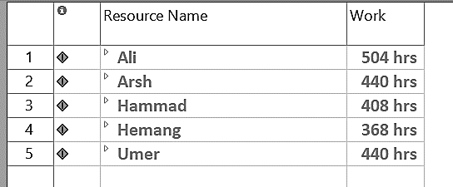

|  |  |
| --- | --- |
| Tools Required | Needed For |
| Laptops, Desktop | Necessary machines, which we will use to make the entire project. |
| MySQL | MySQL will be needed for the database management which will be used to store end user data. |
| Internet Service Provider | To host website online, the basic ISP hosting services will be used |
| Microsoft Teams, Zoom, WhatsApp, Gmail. | Communication tools for project team |
| NodeJS, Mongo DB | Database service providers, which will be used for backend server. |
| JavaScript | A programming language that will be used for the frontend part of website. |
| Angular | Platform to build web application |
| Google Navigation API | It will be used if tourist want to navigate to any business to avail service. |
| GitHub | To be able to share work and know the progress on one single platform |
| Trello | It is needed for assigning any individual work to project team and track the progress of any assigned work. |
| Project 365 | Open-source online project management platform needed for charts (Gantt chart) |
| Google Drive | Needed to share documents and work on a paper together as a team |
| Selenium testing software tool | Open-Source software testing tool will be used for testing |
| Adobe Photoshop | To be used for logo creation |
| Canva | Open-Source Design Software to be used for Logo design |
| Visual Studio Code | Visual Studio Code is a code editor redefined and optimized for building and debugging modern web and cloud applications. |

Table 1 Resources Required

## 1.2 Project Deliverables

A web-based application, technical papers, including codes and images, a test plan, a user manual, acceptance criteria, and a deployment strategy are among the deliverables and results that are to be created within 6 months of project development and documentation period and are to be presented to the client as a solution to the project problem in June 2023.

|  |  |  |
| --- | --- | --- |
| Assessment Task | Due Date | Responsible |
| Initial Product Backlog | 21 August 2022 | All Team Members |
| Ongoing Product Backlog Maintenance | 9 October 2022 | All Team Members |
| Project Handbook   * First version * Second version * Third version | 21 August 2022  28 August 2022  9 October 2022 | All Team Members |
| Sprint Documentation   * Sprint-1 * Sprint-2 | 4 September 2022  3 October 2022 | All Team Members |
| Sprint Demonstration   * Sprint-1 * Sprint-2 | 8 September 2022  6 October 2022 | All Team Members |
| Product Prototype | 9 October 2022 | All Team Members |
| Individual Interview | 29 September 2022 | Individual |
| Individual Contribution   * Sprint 1 * Sprint 2 | 4 September 2022  3 October 2022 | Individual |
| Individual Research Report | 2 October 2022 | Individual |

Table 2 Assessment Tasks

## 1.3 Evolution of the Handbook

Changes are one of the key aspect of project development, which helps to build a better version that is free of any error and accounted as contribution from team members. Every update is thoroughly discussed by each member of team and then it is sent for approval to project manager. Later, project manager (Alihusain) approves or declines it accordingly, if declined it is reviewed again and send for approval again. A project will be completed in five sprints and after the end of each sprint, changes are scheduled and updated. however, it is not strictly limited to this schedule as there may be some circumstances where un-scheduled changes have to be recorded. After successfully updating the handbook, the members of team are informed about changes via Emails, or conference calls.

## 1.4 Reference Materials

* Abdelrahman, M. M., Zhan, S., & Chong, A. (2020). A three-tier architecture visual-programming platform for building-lifecycle data management. *SimAUD*.
* Baumgart, R., Hummel, M., & Holten, R. (2015). Personality traits of Scrum roles in agile software development teams-a qualitative analysis.
* Byrd, J. T., & Luthy, M. R. (2010). Improving group dynamics: Creating a team charter. *Academy of Educational Leadership Journal*, 14(1), 13.
* Camilleri, M. A. (2018). The tourism industry: An overview*. Travel marketing, tourism economics and the airline product*, 3-27.
* Cox, P. L., & Bobrowski, P. E. (2016). The team charter assignment: Improving the effectiveness of classroom teams. *Journal of Behavioral and Applied Management*, 1(2), 789.
* Fernandez, E. B., Fonoage, M., VanHilst, M., & Marta, M. (2008, March). The secure three-tier architecture pattern. In 2008 *International Conference on Complex, Intelligent and Software Intensive Systems* (pp. 555-560). IEEE.
* Gallaugher, J. M., & Ramanathan, S. C. (1996). Choosing a client/server architecture: a comparison of two-and three-tier systems. *Information Systems Management*, 13(2), 7-13.
* Gonçalves, L. (2018). Scrum. *Controlling & Management Review*, 62(4), 40-42.
* Graditi, G. & Di Somma, Marialaura & Ciavarella, Roberto & Valenti, Maria & Cigolotti, Viviana & Kadam, Serdar & Brunner, Helfried & Sosnina, Maria & Khavari, Ata & Calin, Mihai & Ringelstein, J. & Efthymiou, Venizelos. (2018). Project Handbook (DoW).
* Karabulut, A. T., & Ergun, E. (2018). A new way of management: A scrum management. International Journal of Commerce and Finance, 4(2), 108-117.
* Kohl, J. R. (2008). *The global English style guide: Writing clear, translatable documentation for a global market*. SAS Institute.
* Permana, P. A. G. (2015). Scrum method implementation in a software development project management. *International Journal of Advanced Computer Science and Applications*, 6(9), 198-204.
* The Oxford Handbook of Mega Project Management. (2019). *Taylor & Francis*. https://www.tandfonline.com/doi/full/10.1080/14649357.2019.1627127

## 1.5 Definitions and Acronyms

|  |  |
| --- | --- |
| Term | Definition |
| SA | South Australia |
| Project Manager | A person in charge of entire project, is responsible for distributing the work, has authority to take final decision and keeps the project work on track. |
| Sprints | When project is divided into sub-parts, to complete work of that part a dedicated time is allocated, that period of time is known as Sprint |
| Handbook | A piece of document that contains instruction to complete the project |
| MySQL | A form of Database, includes structural set of data on computer |
| ISP | Internet Service Provider |
| Tourism | An act of spending time away from home in pursuing joy and recreation |
| Tourists | A person who is visiting any other place for pleasure and fun |
| Advertise | An act of making something known to people |
| Avail | Using or taking an advantage of any service |
| Service | Any specific type of service that business can provide. |
| Deliverable | Service or any concrete piece of material that is formed after project and has to be submitted to customer. |
| RACI | RACI acronym stands for “Responsible, Accountable, Consulted, and Informed. |
| Scrum | A framework that helps team to work together to generate value through adaptive solutions for complex problems. |
| Documentation | Material that provides valuable and official information that serves as a record. |
| Methodology | A system of methods which are used in a particular area of study |
| Scrum Meetings | It describes different types of meetings held by Scrum team |
| Constructive Criticism | It is considered as clear, direct, honest, and easy to implement advice that is accountable to bring a positive change |
| Constraint | A limitation or restriction |
| Dependencies | It describes relationship among some activities that are dependent on some other activities to be executed. |
| Assumptions | Whenever a thing is accepted true without any solid proof |
| Success Ratio | A win/loss ratio that tells how many times a trader will be successful |
| Testimonies | A declaration that is made by witness under oath |
| Project Cycle | It includes the steps that are required to complete the project: initiating, planning, execution, monitoring, closing |
| End-to-End process | Sequence of processes that give a value stream delivering outcomes. |
| Sitemap | A demo map, which shows the hierarchy of webpages and their routing scheme. |
| Three-Tier Architecture | A 3-tier application architecture is a modular client-server architecture that consists of a presentation tier, an application tier and a data tier. |
| ER Diagram | ER Diagram stands for Entity Relationship Diagram, also known as ERD, is a diagram that displays the relationship of entity sets stored in a database. |

# Organization

## 2.1 Process Model

Project is a combine process of team effort and bringing different ideas into existence. We, altogether 5 people in team are equally contributing to this project where each one of us have put their maximum effort to maximize the efficiency of project. We al-together researched to understand what the project asks us to do in particular. We will be using the SCRUM practices, which is the product of agile project development methodology to complete this project. In this the entire project is broken down into list of functionalities, where each functionality is done in the iteration of Sprints. Whenever one sprint is completed, it will become an independent part of the project that can be delivered, no matter if other sprints are still in developing phases.

|  |  |  |
| --- | --- | --- |
| Team Member | Responsibility | Outcome |
| Arsh Chawla | * Research on Project * Documentation | Arsh took the responsibility, where he researched about tourism industry in depth and identified some of key problem this industry is facing.  As it is very important to keep record of accomplishment of every phase of project cycle, Arsh was made accountable to document everything. |
| AliHusain Charolia | * Project Planning * Team Meetings | Alihusain enabled the project planning, created Trello board, reviewed, and approved project documentation and kept the way out of every problem our project can have.  Alihusain makes sure that the meetings between team members are organized often, which would increase the affection among themselves, and they would be updated with every new work being done. |
| Umer Nazir | * Project Design * Graphic Designing | Umer researched about the project design, as how the project will come into existence.  Umer is accountable for every piece of graphic being used in either documentation, or website. |
| Hemang Desai | * Implementation Plans * Testing | Hemang is conducting a research on how project will be executed, and steps involved  Hemang makes sure that every new development is tested through software and bugs are reported to project manager. |
| Hammad Jawaid | * Get feedback * Programming | Feedback is the one thing, which keeps the evolution of project alive, Hammad, makes sure that market feedback comes in very handy.  Hammad took the responsibility of coding the website according to user requirement. |

Table 3 Team Member Responsibility and Outcome

Mainly Scrum methodologies consists of six stages, which help to complete the project very smoothly.

|  |  |
| --- | --- |
| Stage Name | Description |
| Organize the Backlog | This stage is also known as backlog grooming, which is the responsibility of product owner. He uses the vision of project to create the backlog according to user stories. |
| Sprint Planning | In this stage, the backlog is further divided into iteration of sprints, where each item of backlog is setup with priority and then added into sprint. At the end of this stage, team members should be clear about the vision of the project, and what should be delivered in the particular sprint. |
| Sprint | It is the actual time, when the entire team works together in the development of the defined functionalities. Usually, the time of sprint lasts for about 2 weeks, but it can vary according to the user stories defined in that particular sprint. |
| Stand up | This stage is very important where the team will have a short meeting in order to share the progress of the project. The stand-up meetings are always held on the working hour and would not last more than 15 minutes. It gives the sense of idea on tracking down the progress of project. |
| Sprint review | After completing the iteration of any sprint, the team will review each other’s work and the entire increment overall. The team will discuss the feedback of all the stakeholders, and the product owner will decide whether to release the particular sprint or not. |
| Sprint Retrospective | This is the final stage of the Scrum practice, where the team will sit back and review the increment and discuss where we went wrong and what can be improved in upcoming iterations or project. |

Table 4 Process Model of Scrum six stages

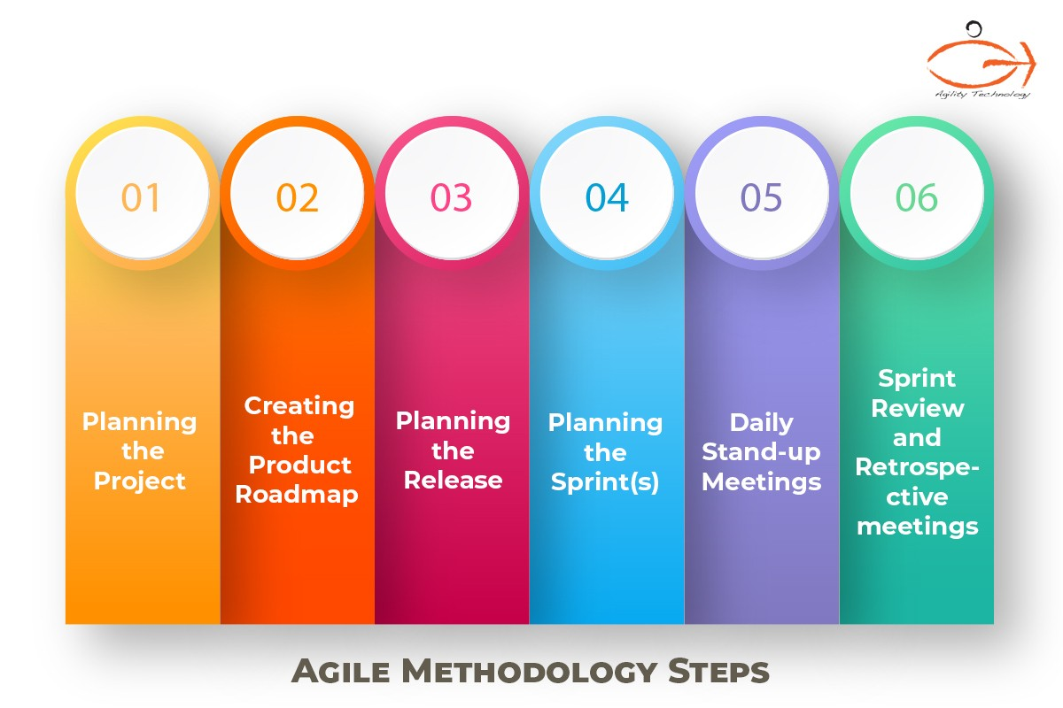

Figure 1 Six stages for Agile Scrum Practices

*Image Source:* [*https://agilitytechnology.com/agile-methodology-steps/*](https://agilitytechnology.com/agile-methodology-steps/)

High-level breakdown of the activities (Sprint 1 and Sprint 2), with a rough timeline:

Below is the list of tasks, their estimated duration. Using the below list Gantt Chart was created which is attached below.

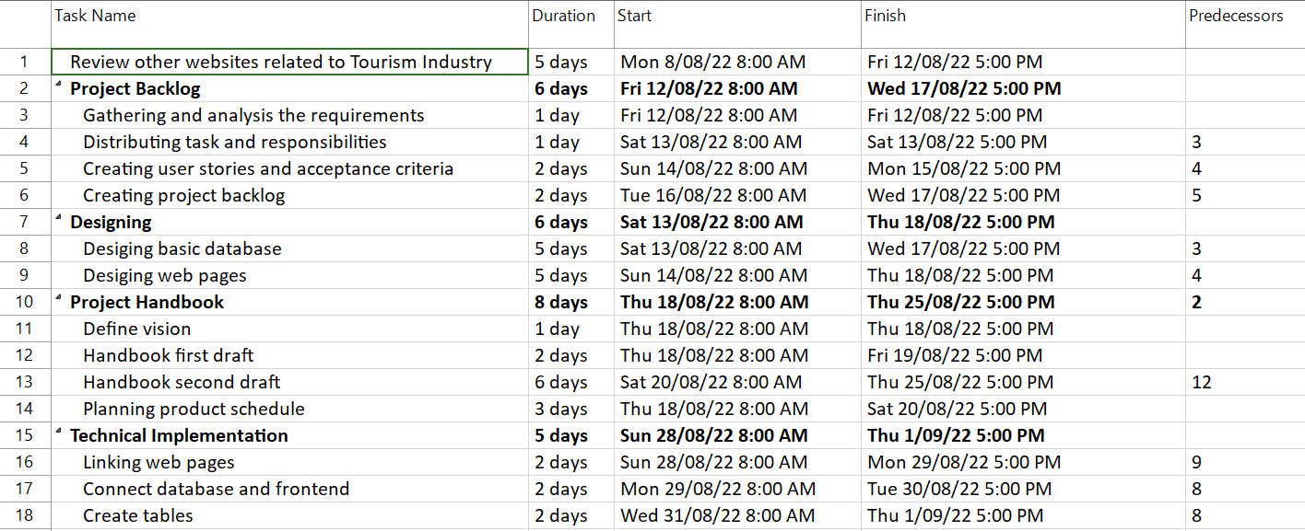

Gantt Chart:

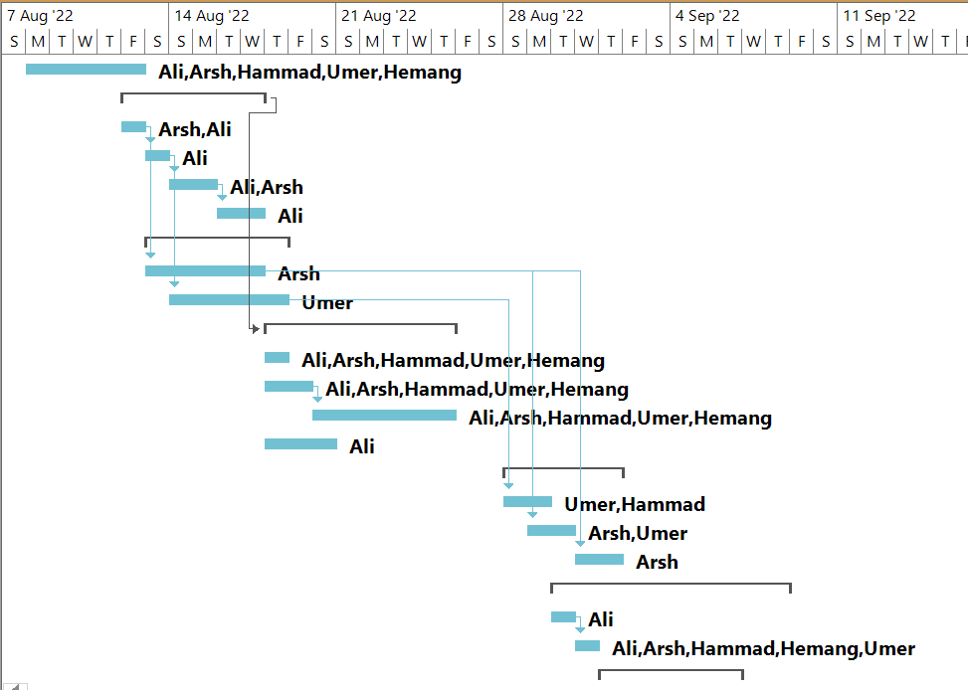

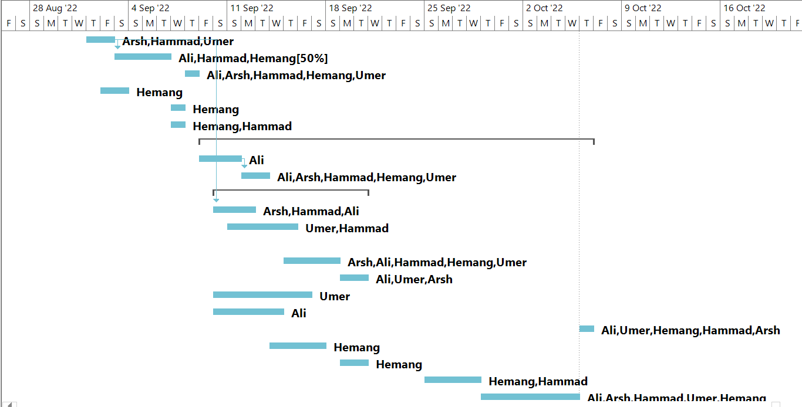

Sprint 1 User Stories and Tasks:

|  |  |  |
| --- | --- | --- |
| Requirement | Condition of Satisfaction | Tasks and Estimates |
| US1 As a Tourists and Business owner, I want to sign-up/sign-in/sign-out of the web application | - Able to gain full access to the web application  - Able to generate sign-up form including Name, Phone number, Email Address, Address and Password  - Able to complete the sign-up form and register  - Able to sign-in with specific email address and password.  - Able to sign-out of the application | T1: For Tourists and Business owner, the sign-up/sign-in/sign-out options and forms should be available - 2 days (Hammad)  T2: The user should be submitting the form online, and the backend code must be able to store the user information in the database – 1 day (Arsh)  T3: Create a Webpage to show the successful creation of login - 12 hours (Umer) |
| US5 As an Administrator, I want to be able to sign-in/sign-out of the web application | - Able to gain full access to the web application  - Able to sign-in with admin email address and password.  - Able to sign-out of the application | T4: For Administrator sign in web page should be available and can sign out using a button – 1 day (Umer & Hammad) |
| US12 As a Business Owner, I want to reset my password in case I forget my login credentials | - Business owner must have access to login page  - Business owner must be able to click on forget password  - On new webpage Business owner must be able to enter their email address  - Business owner must be able to see message “Email sent successfully”  - Business owner should be able to set new password from the email received  - Business owner must be able to use new password to login to the website | T5: Business owner clicks the links, which is directed to reset password page. 12 hours (Hammad & Alihusain)  T6: Page asks verification fields and sends an email for pin. 12 hours (Hammad & Umer)  T7: User is redirected to a new page for new password. 1 day (Alihusain & Hemang)  T8: New password is updated in database. 1 day (Arsh) |
| US21 As a Tourist, I want to reset my password in case I forget my login credentials | - Tourist must have access to login page  - Tourist must be able to click on forget password  - On new webpage Tourist must be able to enter their email address  - Tourist must be able to see message “Email sent successfully”  - Tourist should be able to set new password from the email received  - Tourist must be able to use new password to login to the website | T9: Tourists clicks the links, which is directed to reset password page. 12 hours (Hammad & Alihusain)  T10: Page asks verification fields and sends an email for pin. 12 hours (Hammad & Umer)  T11: User is redirected to a new page for new password. 1 day (Alihusain & Hemang)  T12: New password is updated in database. 1 day (Arsh) |

Table 5 Sprint 1 User Stories and Tasks

Sprint 2 User Stories and Tasks:

|  |  |  |
| --- | --- | --- |
| Requirement | Condition of Satisfaction | Tasks and Estimates |
| US3 As an Administrator, I want to be able to block/ban certain users who violate community guidelines | - The admin must be logged in to the website  - The admin must traverse to user management web page  - Admin must be able to click “Block” button to block user ID | T1: Admin should be able to find out the relevant users when he types out any name. - 9 hours (Hammad & Alihusain)  T2: A flag should be generated whenever any user has reported any other user so that the system of automation can increase. 2 days (Hammad & Arsh)  T3: The status of blocked user is converted into “blocked” so that whenever he tries to login, he gets alert message stating that he has violated guidelines and is blocked now. 1 day (Alihusain & Arsh) |
| US2 As an Administrator, I want to add, update, or remove the Business details | - The admin must be logged in to the website  - The admin must be able to traverse to webpage  - The admin must be able to see the lists of business added  - The admin must have button to update, delete and add business | T4: For Administrator, a separate page has to be designed which will show admin to see the list of all the business– 1 day (Umer & Hammad)  T5: CRUD system of the database is to be setup properly so that if user removes or updates anything it should be done for all the places where that particular data is present. 12 hours (Arsh)  T6: The page designed to have Add, Update and Delete Button. 5 hours (Umer) |
| US10 As a Business Owner, I want to add multiple services under one account | - Business owner must be logged in to the website  - Business owner must have access to the dashboard  - Business owner must be able to click on “Add Business” Button.  - Business owner must be directed to a page to enter business name and details  - Business owner must be able to save the details  - Business owner must get message saying details saved | T10: Business owners gets directed from dashboard to a new page where he can see all his services. 12 hours (Hammad & Alihusain)  T11: A button, which will lead him to a new page where he can post about his new business. 6 hours (Hammad & Umer)  T12: New business should be visible to trending services at user’s end and the entire business list under admin list. 1 day (Arsh & Hemang) |
| US26 As a tourist, I want to view services offered by businesses. | - Tourists when opens the website must be able to see trending businesses  - When clicks on “All Businesses” must be directed to a new page where all businesses are listed | T13: Tourists should be able to view all the businesses via Card design on the webpage. 6 (Umer & Ali)  T14: Database linked so businesses details saved by admin and business owners can be retrieved on frontend for user to see. 5 hours (Arsh & Umer) |

Table 6 Sprint 2 User Stories and Tasks

Preliminary agreed dates for sprint review meetings for demonstrations to client are as below:

Project Team has arranged meeting with client arranged every fortnight on Thursday in IIBIT Adelaide Campus or on Zoom.

* Sprint 1 Documentation, Teamwork and Sprint demonstration: 1st September 2022 Thursday
* Sprint 2 Documentation, Teamwork and Sprint demonstration: 29th September 2022 Thursday

## 2.2 Organizational Structure

The structure of our team supports a group work where tasks are divided and allocated to everyone based on their expertise. For completing this project within given timeframe and budget, we implemented Agile Development technique, which in particular is known as Scrum Methodology. A unique project management system relies on incremental development where the tasks are divided in different iterations of sprints. There are certain roles and responsibilities defined in scrum methodology which helps project to maximise the efficiency and put track of project development on point. Below are scrum roles and responsibilities allocated to different team members.

|  |  |  |
| --- | --- | --- |
| Scrum Roles | Allocated Members | Responsibilities |
| Scrum Master | AliHusain Charolia | * Lead Scrum Planning sessions * He is responsible for organization meetings. * Enables team meetings. * Ensure the good relation between team and product owner * Keep all stakeholders of project on track and informed. * Manages any problem that arises for the team by communicating with stakeholders outside the team. * Ensures that Scrum Practices and Principles are followed * Binds project team members to have a healthy development. |
| Product Owner | Arsh Chawla | * Explains the project overview and product vision for team. * Manage and prioritize product backlog and divide task in iterations of sprints. * Evaluate team progress and making sure that team is focused and working on right track. * Communicate with external stakeholders and keep their needs or changes informed to team members. * Evaluate Work done by Development team and provide them constructive criticism. * Responsible for successful business strategies. |
| Development Team | Umer Nazir  Hemang Desai  Hammad Jawaid | * Help in Sprint planning and goal setting * Perform Sprint Execution * Participate in daily Scrum practices that are aimed to archive high quality of project * Design, build, and test the product |

Table 7 Scrum Roles, Allocated Members and Responsibilities

The Project Team Structure is as below:

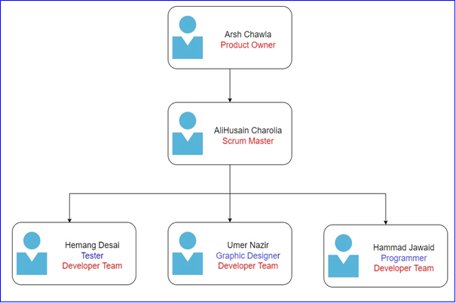

Figure 2 Team Organisation

Changes plays one of the important role that helps to achieve high quality of project with reference to every team member. Roles of Scum are assigned with respect to specific skills of every member but can be changed with context to project quality. For that, Daily Scrum meetings will be held, where product owner will inspect the progress of development team and guides if anything is necessary to be added. On the other hand, Scrum master will ensure that development team is having daily meeting and will conduct some fun exercise that will help to improve the communication within team.

## 2.3 Organization Boundaries and Interfaces

There are certain boundaries defined which ensures a healthy relationship between project team and all other project stakeholders. Client Mike Vu has discussed the project in depth including its key features and functionalities. We get client’s feedback on the work done, which improves the quality of project. In this project, mainly all team members are equally responsible to discuss project progress with client, however, Alihusain Charolia and Arsh Chawla being scrum master and product owner have the responsibility to discuss the project progress and work with client and also responsible for any major change that is to be discussed with client. Team is responsible for fortnightly physical meetings with Mike where he checks the ongoing work and provides constructive feedback. Scrum Master stays in touch with client via email as well to get feedback on the ongoing project documentation and work. Nordiana Shah is Project Mentor who guides us with any project related query that we have, and we have physical meetings with Nordiana weekly every Thursday.

|  |  |
| --- | --- |
| Role | Name of Person |
| Client | Mike Vu |
| Project Company | Komorebi |
| Project Sponsor | Mike Vu |
| Project Owner | Arsh Chawla |
| Scrum Master | AliHusain Charolia |
| Development Team | Umer Nazir, Hammad Jawaid, Hemang Desai |
| End User | Business Owners, Tourists, Staff of Komorebi |
| Project Mentor | Nordiana Shah |

## 2.4 Project Responsibilities

Every member in team has expertise in different areas, thus the project work is divided and is assigned to the relevant team members. Below is RACI Matrix that states all the project stakeholders working on the project and their level of involvement in each task which is denoted with the letters R, A, C, or I.

* Responsible - Person working on Activity
* Accountable - Person with decision Authority
* Consulted - Key stakeholder who should be contacted for any decision
* Informed - Person who needs to know the decision or action

RACI Matrix:

|  |  |  |  |  |
| --- | --- | --- | --- | --- |
| Task | Responsible | Accountable | Consulted | Informed |
| Model User Requirement | Hemang Desai | Arsh Chawla | Hammad Jawaid  Umer Nazir | AliHusain Charolia |
| Behaviour Diagram | Umer Nazir | Umer Nazir  Arsh Chawla | AliHusain Charolia | Hammad Jawaid |
| Structure Diagram | AliHusain Charolia | Umer Nazir | Hammad Jawaid | Arsh Chawla |
| User Interface | Hammad Jawaid | AliHusain Charolia | Arsh Chawla | Umer Nazir |
| User Experience | Umer Nazir  Hammad Jawaid | Umer Nazir | Arsh Chawla | AliHusain Charolia |
| Quality Assurance | AliHusain Charolia | Umer Nazir  Hemang Desai | Arsh Chawla | Hammad Jawaid  Hemang Desai |
| User Documentation | Arsh Chawla | Arsh Chawla | Hammad Jawaid | AliHusain Charolia |
| Technical Documentation | Arsh Chawla | Arsh Chawla | Hammad Jawaid | AliHusain Charolia |
| Prototype | Hammad Jawaid  Umer Nazir | Hammad Jawaid | Arsh Chawla  AliHusain Charolia | AliHusain Charolia |
| Selenium Testing | Hemang Desai | Hemang Desai  Hammad Jawaid | Arsh Chawla  AliHusain Charolia | Umer Nazir |
| System Analyst Designer | Umer Nazir | Hammad Jawaid  AliHusain Charolia | Hemang Desai | Arsh Chawla |

Table 8 RACI Matrix

# Managerial Process

## 3.1 Management Objectives and Priorities

It is very important to have a strategic approach that guides how a manager leads their team and makes best decision which not only brings quality in project but ease up work for team. This is what accounts as pillar of ***management philosophy***. The term itself is a self-explanatory, which populates management with the world of philosophical nature. The philosophy ensures a supportive atmosphere, which leads to an effective and efficient completion of project. This also channels a strong communication lines with our client and team that brings feedback on each step of development so that we can correct errors, before moving further. In extensive projects like these, teamwork is one of the most essential essence that brings out the quality of work. So, in our team, we discuss everything from development model to testing the final product functionalities, and every opinion that comes is as respected as the feedback from the client. We make sure that if any member of our team is struggling with their portion of work; we all come together and help each other. These practices of positivity keep the moral, motivation, and mindset of team very high, which enables us to complete the project with scheduled timeframe and budget. In case of conflict, we leave final decision to be made by scrum master with the feedback from the client with which team agrees.

Indeed, we are aiming for quality performance, keeping our high spirit to complete the expectations of our client and provide our community a platform where tourism will no longer be a headache to plan rather a fun and joyful activity. We plan to have a better user experience that will make sure that all requirements of user are completed with ease. Apart from it, with this project we also wish to learn new skills that can help us in our future IT career. A spark of teamwork, time-management, business management, communication and technical skills has intrigued us, and we intend to achieve excellence in it by the end of this project.

## 3.2 Assumptions, Dependencies, and Constraints

There are few assumptions, dependencies, and constraints, which come under the development of the project, and it is always considered a best practice to note them down before development so that unseen circumstances can be handled easily.

|  |  |
| --- | --- |
| No | Assumption |
| 1 | All the project tasks that are planned and arranged will be followed with the guidelines described by Project head. |
| 2 | All the deliverables will be completed within the timeframe and each request sent by client will be processed in minimal of time. |
| 3 | Project team members will have all the resources available to complete the project within given time and estimated budget. |
| 4 | The scope of the project will not change throughout the life cycle. |
| 5 | All the project equipment used in project development, such as computers, Microsoft Teams, Microsoft Office, and JavaScript framework will be in working during the project life cycle. |
| 6 | All project team members will put in equal efforts and are available during the complete period of project development. |
| 7 | Project requirements are clearly understood by all project team members. |

Table 9 Assumptions

|  |  |
| --- | --- |
|  | Dependencies |
| 1 | The feedback and quality of project is still dependent on client so that any errors can be corrected at that time without moving further so client have to give us time to discuss the progress of projects and knowing things in more detail. |
| 2 | Our team is dependent on our tutor and project owner of this project for constructive criticism and guidance to improve the quality of project. |
| 3 | The project is relied upon team member’s efficiency to complete the project work allocated to them. |
| 4 | The resource-based dependency can occur if the resource is already in use so other task has to wait until the resource becomes available. Recourse can be a team member, software, or hardware. |

Table 10 Dependencies

|  |  |
| --- | --- |
| No | Constraints |
| 1 | Every task of project has to be completed within specified sprint time so that the deadline of estimated time can be fulfilled. |
| 2 | The scope of the project must be clearly addressable and understandable to every linked stakeholder, and it should not change within the life cycle. |
| 3 | Technology used in the development phase must be updated and must not contain any problem that can produce delay in tasks. |
| 4 | Customer needs and its satisfaction must be clearly kept in mind. Team needs to thoroughly follow all the stated requirements regardless of their relevance in project. |
| 6 | Working on this project, we are required to work only with people in our team, which restricts the bounds of skills of extremely limited people. |
| 5 | Project budget must be considered while selecting any tools and technologies for project development as cost is the biggest constraint. |

Table 11 Constraints

# Technical Process

## 4.1 Methods, Tools, and Techniques

The complete project development relies on the usage of multiple tools that helps to ease up the work and ensures the quality of final product. Development tools used for project management and software development are:

|  |  |
| --- | --- |
| Tools | Needed For |
| Laptops, Desktop | Necessary machines, which we will use to make the entire project. |
| MySQL | MySQL will be needed for the database management which will be used to store end user data. |
| NodeJS, Mongo DB | Database service providers, which will be used for backend server. |
| JavaScript | A programming language that will be used for the frontend part of website. |
| Angular | Platform to build web application |
| Google Navigation API | It will be used if tourist want to navigate to any business to avail service. |
| GitHub | To be able to share work and know the progress on one single platform |
| Trello | It is needed for assigning any individual work to project team and track the progress of any assigned work. |
| Project 365 | Open-source online project management platform needed for charts (Gantt chart) |
| Google Drive | Needed to share documents and work on a paper together as a team |
| Selenium testing software tool | Open-Source software testing tool will be used for testing |
| Adobe Photoshop | To be used for logo creation |
| Canva | Open-Source Design Software to be used for Logo design |
| Microsoft Windows Operating System | We are using Windows 10 for running every software and building this project |
| Foxit reader 6.0 | For creating and viewing PDF |
| Microsoft Project 2010 | It is used to create WBS structure, Schedule/cost resources planning and project control |
| Microsoft Office 2010 | Creating and editing documents |
| Microsoft PowerPoint 2010 | Throughout this project, presentations are very important to highlight the development. |
| Visual Studio Code | Programming Idle software that will be used for coding the project |

Table 12 Tools

The scrum framework directs product development, emphasising value and high progress visibility. A scrum team creates the product from a concept by working from a dynamic list of the most important tasks, using the scrum architecture to promote transparency, inspection, and adaption. Scrum aims to facilitate team collaboration so that teams can delight clients.

Scrum framework has eased up our team a lot in managing the entire project. This has saved us a big amount of time by layering project into incremental phases where the result of one task sequentially serves as the feedback to next task. The Scrum framework is very similar to Agile; however, Agile is a mindset whereas Scrum is an execution of those principles of mindset. Moreover, as this project requires documentation of each thing, Scrum enables us to build a proper documentation of each individual phase which enables transparency. The success ratio of Scrum testimonies is much better than other project development methods as it provides the detail study of project-cycle.

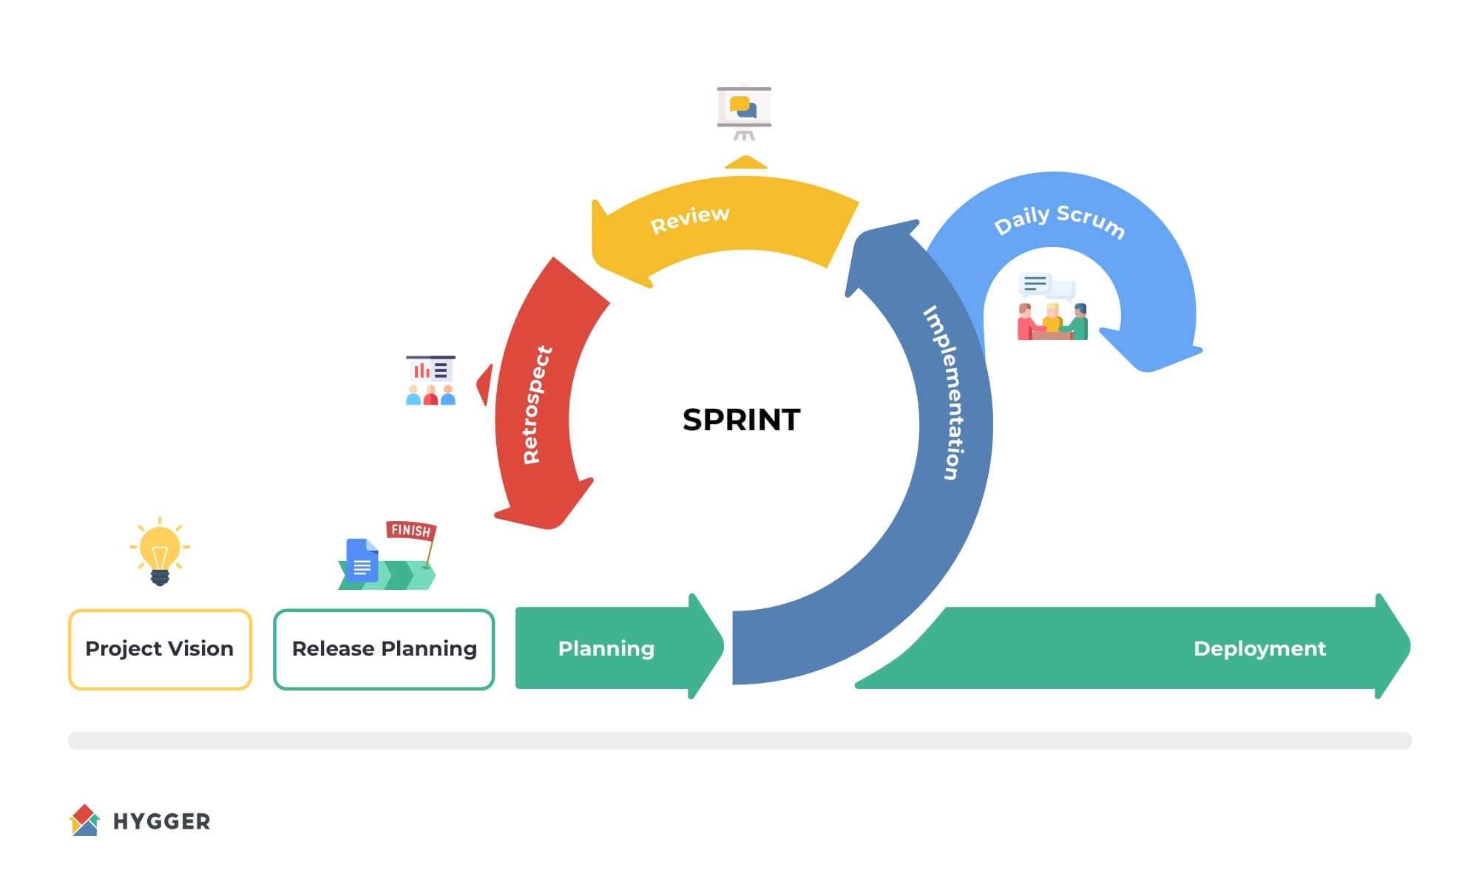

Figure 3 Scrum Framework

https://hygger.io/guides/agile/scrum/scrum-artifacts/

The above diagram shows the steps involved in scrum framework that will be followed to develop web application of SA Tourism Booster. The project will start with collecting user’s data and their requirements, which will help us to create user stories/product backlog with their priorities. The completion of project will be done in iterations of five sprints, each sprint will last for 4 to 5 weeks. During the sprint, the tasks from backlog will move towards sprint goals where daily stand-up will enable team members to be updated on work being done. The development of each sprint will be thoroughly tested, if any error is encountered, it will be reported to the project manager. As project cycle comes to end, we will be having our working application that will be demonstrated to client along with assessments, sprint retrospective to be submitted to project supervisor.

Without strong communication medium, it is nearly impossible to work effectively, manage teams and co-ordinate efforts to bring successful outcome from the project. Communication is must at personal, team and organisation level. For communication, we are using following tools:

|  |  |
| --- | --- |
| Tools | Used For |
| Microsoft Teams | It is used for meetings if cannot meet face to face. |
| WhatsApp | Another tool for communication mainly used for texting in groups |
| Emails | To share files with team and client |
| Telephones | To have telephonic conversation with team members |
| Trello | A project board that communicates a way to capture the work that is planned, in progress and completed.  Link: <https://trello.com/b/fRZ8oisZ/project-management-sa-tourism-booster> |

Table 13 Communication Tools

Software design is a process that transforms the user requirements/stories into graphical representation. Software design is the initial step in Software Design Life Cycle (SDLC), which shifts the focus from problem domain to solution domain. Further the software design tries to identify how to fulfill the requirements mentioned in Software Requirement Specification (SRS). Below are some diagrams that will be initially used:

|  |  |
| --- | --- |
| Diagram Technique | Used For |
| Data Flow Diagram | DFD is a graphical representation that highlights the data flow within the system that enables team to understand the process aspects. However, it does not mention technical details such as timing and nature of processes such as sequential or parallel, but it can be used to visualize the process of entire system. Analysts can easily observe the input and output of data, which can be used in data -modelling. |
| Context Diagram | This diagram enables team to understand the connection and relationship of system with external entities. |
| Pseudo-code | It is considered as one of optimal way, which explains how an algorithm works. It is presented in a natural language that even non-technical stakeholders can easily understands. It provides a comprehensive outline of entire code that enables programmers to understand the software process. |
| Flow Chart | It is a graphical visualizing technique; it will be used to break down the process of algorithm in steps. Flow charts come very handy in the fields of analysis, design, and documentation of any system as the diagrams are very easy to understand. |

Table 14 Diagrams Used

As all 5 member of team will be working on this project, to make sure everyone can work on and have access to code we are using GitHub, which is considered as best hosting service for software development.

Link for GitHub repository is: <https://github.com/TravelCare01/travelCare.git>

## 4.2 Software Documentation

Software documentation is a major part of software development. It enables stakeholders to understand the program with written content, pictures, diagrams, and videos. For documenting our project, we will be using the style guide by Kohl, 2008 which sets the standard of clear writing and formatting. There is some key type of documentations, which will be created throughout project life cycle:

|  |  |
| --- | --- |
| Documentation type | Used for |
| Architecture | This type of documentation will contain information related to high-level architecture of developed software system. It will provide the insights into the main components of entire system, their roles, and functions, which then eventually leads to data and control flow. |
| Technical | This document will be generally for programmers to help them, it will have the algorithms used in developing the system. It will also contain source code of project with different APIs used. |
| Requirements | This is the foundation of entire project, which is created at the start of development phase. It clarifies the objectives, specification, vision, and project scope that can help developers to develop accordingly. It may also include functional and non-functional requirements that describes the combability of entire system. |
| End-User | This documentation brings us to the last phase of development, which is created for end users for a product or service. This contains company’s manual, which explains the usage of software and its services. It can be in the form of handbooks, manual, or electronic material. |

Table 15 Documentation Type

Documentation provides team to list the key-features of entire project life cycle, thus it becomes necessary to review it for accuracy so that there is no room for errors. Thus, there are three areas of focus, which will generally be used to test our documents.

|  |  |
| --- | --- |
| Testing Strategy | Used for |
| Review | This is a very generalized level of testing that focuses on high level of examination that checks whether the required content is present and free of any obvious errors |
| Study | This is the second layer of testing that is more focused and checks the in-depth requirements of documents. |
| Analyse | This comes under the second layer, where a rigor and detailed examination is done. It would analyse whether the document is correct, complete, and consistent. |

Table 16 Documentation Testing Strategy

# High level Project Plan

The project altogether is divided in the iterations of 5 sprints, the entire project is divided into each sprint based on their priority and relevance to the time being. The detail of each sprint is listed below.

Sprint 1:

This is the very first stage of the project, where we are doing our initial research about the project vision and scope to determine what technologies we can use in this project. We will be building a suitable logo for the main page of website and highlighting it on the business card so that purpose of project can be conveyed. Before going into actual code, website wireframes will come into play where our graphic designer will design the website pages according to user stories. The main part of every project, which is enabling all entities to login into website, will also be done in this sprint. Email verification, where user’s identity will be verified through a security code to be completed here as well.

Duration: 08/08/2022 – 08/09/2022

|  |  |  |
| --- | --- | --- |
| Sprint | Requirement | Condition of Satisfaction |
| 1 | US1 As a Tourists and Business owner, I want to sign-up/sign-in/sign-out of the web application | - Able to gain full access to the web application  - Able to generate sign-up form including Name, Phone number, Email Address, Address and Password  - Able to complete the sign-up form and register  - Able to sign-in with specific email address and password.  - Able to sign-out of the application |
| 1 | US5 As an Administrator, I want to be able to sign-in/sign-out of the web application | - Able to gain full access to the web application  - Able to sign-in with admin email address and password.  - Able to sign-out of the application |
| 1 | US6 As an Administrator, I want to change my password even if I remember my current one | - Admin must have access to login page  - Admin must be able to click on forget password  - On new webpage Admin must be able to enter their email address  - Admin must be able to see message “Email sent successfully”  - Admin should be able to set new password from the email received  - Admin must be able to use new password to login to the website |
| 1 | US12 As a Business Owner, I want to reset my password in case I forget my login credentials | - Business owner must have access to login page  - Business owner must be able to click on forget password  - On new webpage Business owner must be able to enter their email address  - Business owner must be able to see message “Email sent successfully”  - Business owner should be able to set new password from the email received  - Business owner must be able to use new password to login to the website |
| 1 | US13 As a Business Owner, I want to change my password even if I remember my current one | - Business owner must have access to login page  - Business owner must be able to click on forget password  - On new webpage Business owner must be able to enter their email address  - Business owner must be able to see message “Email sent successfully”  - Business owner should be able to set new password from the email received  - Business owner must be able to use new password to login to the website |
| 1 | US21 As a Tourist, I want to reset my password in case I forget my login credentials | - Tourist must have access to login page  - Tourist must be able to click on forget password  - On new webpage Tourist must be able to enter their email address  - Tourist must be able to see message “Email sent successfully”  - Tourist should be able to set new password from the email received  - Tourist must be able to use new password to login to the website |
| 1 | US22 As a tourist, I want to change my password even if I remember my current one | - Tourist must have access to login page  - Tourist must be able to click on forget password  - On new webpage Tourist must be able to enter their email address  - Tourist must be able to see message “Email sent successfully”  - Tourist should be able to set new password from the email received  - Tourist must be able to use new password to login to the website |

Sprint 2:

This is the stage, where the basic functionality of entire website has to be completed. This will be more centric to Admin rights and its power to maintain the website norms, such as blocking any user if he/she violates the community guideline. This sprint will also make sure that business owners are able to add multiple businesses under their page, so that every user can see it in trending services page and can avail any service accordingly.

Duration: 09/09/2022 – 06/10/2022

|  |  |  |
| --- | --- | --- |
| Sprint | Requirement | Condition of Satisfaction |
| 2 | US3 As an Administrator, I want to be able to block/ban certain users who violate community guidelines | - The admin must be logged in to the website  - The admin must traverse to user management web page  - Admin must be able to click “Block” button to block user ID |
| 2 | US2 As an Administrator, I want to add, update, or remove the Business details | - The admin must be logged in to the website  - The admin must be able to traverse to webpage  - The admin must be able to see the lists of business added  - The admin must have button to update, delete and add business |
| 2 | US10 As a Business Owner, I want to add multiple services under one account | - Business owner must be logged in to the website  - Business owner must have access to the dashboard  - Business owner must be able to click on “Add Business” Button.  - Business owner must be directed to a page to enter business name and details  - Business owner must be able to save the details  - Business owner must get message saying details saved |
| 2 | US26 As a tourist, I want to view services offered by businesses. | - Tourists when opens the website must be able to see trending businesses  - When clicks on “All Businesses” must be directed to a new page where all businesses are listed |

Sprint 3:

The goals of Sprint 3 are more concerned to the main features of this website on which the entire vision is dependent. For business owners, they must be able to collaborate with other owners to offer a combined deal in order to benefit the tourists. On the other hand, customers should also be able to book/join any services they wanting to explore, also if not booking can have option to add them to Wishlist so can come later to review.

Duration: 01/03/2023 – 13/04/2023

|  |  |  |
| --- | --- | --- |
| Sprint | Requirement | Condition of Satisfaction |
| 3 | US9 As a Business Owner, I want to be able to connect with other businesses to collaborate and offer join deals to tourists | - Business owner must be logged in to the website  - Business owner must have access to view services offer by other businesses  - Business owner must be able to click on “Message now” to connect with other business owners  - Business owner must get message saying “Message Sent” |
| 3 | US14 As a Business Owner, I want to know how many tourists viewed my services | - Business owner must be logged in to the website  - Business owner must have access to the dashboard  - Business owner must be able to see number of users who clicked their business link |
| 3 | US17 As a Tourist, I want to book/join any service/deal that I like | - Tourist must be logged in to the website  - Tourist must have access to special deals and offers webpage  - Tourist must be able to click on “Add to Cart” button for the service they would like to join/purchase or book  - Tourist must be able to checkout |
| 3 | US23 As a tourist, I want to select multiple businesses/services and add them into my Wishlist | - Tourist must be logged in to the website  - Tourist must have access to view services provided by various businesses  - Tourist must have option to add selected services to their Wishlist  - Tourist must be able to see message “Service added to Wishlist” after they have actioned  - Tourist must have access to view Wishlist to see the added services |

Sprint 4:

The goal of the sprint 4 is to allow businesses to add and update time limited discounts and on other hand allowing tourists to see same discounts and deals from front end of the website. Further allowing business owner and tourists to communicate with each other.

Duration: 14/04/2023 - 19/05/2023

|  |  |  |
| --- | --- | --- |
| Sprint | Requirement | Condition of Satisfaction |
| 4 | US7 As a Business Owner, I want to be able to provide time-limited discounts and deals on my services | - Business owner must be logged in  - Business owner must be able to traverse to webpage for adding discounts and deals  - Business owner must be able to add an end date to the deal or discount  - Business owner must be able to save the information and see the message as per their action |
| 4 | US11 As a Business Owner, I want to update the discounts and deals added to my services | - Business owner must be logged in to the website  - Business owner must have access to the dashboard  - Business owner must have option to add discount to any service added  - Business owner must be able to come back and update the discounts and deals added to the services |
| 4 | US16 As a Tourist, I want to view special deals or offers by multiple businesses | - Tourist must have access to the website  - When Tourist opens the website must be able to see special deals and offers webpage |
| 4 | US15 As a Business Owner, I want to send message to tourists to connect with them | - The Business owner must be logged in to the website  - The Business owner must be able to access the dashboard  - The Business owner must be able to see the lists of tourists  - The Business owner must have option to open tourist’s profile  - The Business owner must have option to type and send the message  - The Business owner must be able to see the related message saying “Message sent” |
| 4 | US18 As a Tourist, I want to communicate with the business owner to know more about the offered services | - Tourist must be logged in to the website  - Tourist when opens the website must be able to see trending businesses  - When clicks on “View More” must be directed to a new page where all businesses are listed via cards  - Using “Message now” button on the card, Tourist must be able to send message to the business listed  - Tourist must see message saying “Message sent” |

Sprint 5:

The goal of this sprint is to allow admin more access to be able to edit web content where required. Also allowing users (business owners and tourists) to edit their own profile and deactivate when they wish to. With this user feels the web application is for them and behaves as they want it to. Furthermore, allowing tourists to keep track of their past orders and also assisting tourists with navigation so they can reach the business location with ease.

Duration: 20/05/2023 23/06/2022

|  |  |  |
| --- | --- | --- |
| Sprint | Requirement | Condition of Satisfaction |
| 5 | US4 As an Administrator, I want to be able to add, update or remove content from the web app | - The admin must be logged in to the website  - The admin must traverse to web content management web page  - Admin must be able to click add, update and remove button  - Admin must be able to see message as per the action performed |
| 5 | US8 As a Business Owner, I want to edit my profile (business working hours, business name, business address etc.) | - Business owner must be logged in  - Business owner must be able to traverse to webpage called “My profile”  - Business owner must be able to edit and save the changes made  - Business owner must be able to see the message related to their action |
| 5 | US19 As a tourist, I want to update my profile (Address, mobile etc.) | - Tourist must be logged in  - Tourist must be able to traverse to webpage called “My profile”  - Tourist must be able to edit and save the changes made to their address, mobile etc.  - Tourist must be able to see the message related to their action |
| 5 | US20 As a tourist, I want to delete my account if needed | - Tourist must be logged in  - Tourist must be able to traverse to webpage called “My profile”  - Tourist must be able to see a button called “Deactivate account”  - Tourist must be able to click the button to deactivate their profile |
| 5 | US24 As a tourist, I want to view my history of activities or deals that I’ve purchased from multiple businesses so that it would be easier for me to track if I visit SA again | - Tourist must be logged in to the website  - Tourist must have access to webpage “Purchase History”  - Tourist must be able to see list of services they purchased |
| 5 | US25 As a tourist, I want the web application to navigate me to the business I am interested in. | - Tourist must have access to the website  - Tourist must be able to view all businesses  - Tourist must be able to open the business card they are interested in  - Tourist must have clickable address link on the webpage that open navigation application |

Work Breakdown Structure:

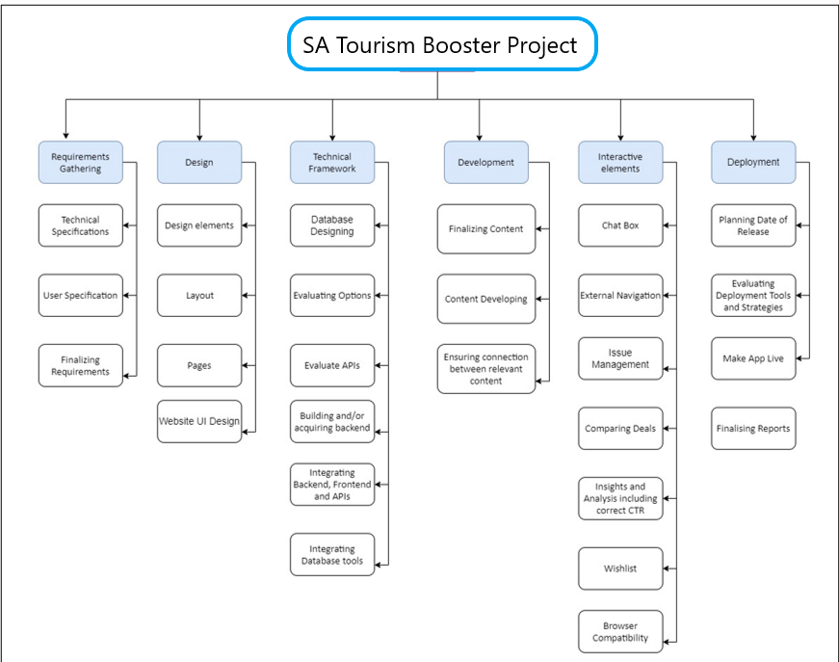

Figure 4 WBS

The link for the Trello board, where all the backlog and sprint are maintained is <https://trello.com/b/fRZ8oisZ/project-management-sa-tourism-booster>

# Non-functional Requirements

There are two types of requirements in any project; one is functional requirements, which means that they are necessary in terms of building the basic requirements of project. While non-functional requirements refer to those specifications, without them, the project will still work. They are set of specifications that describes the system’s operation capabilities and constraints.

## 6.1 Platform

The SA Tourism Booster website is platform independent as the coding done on it supports latest type and versions of platform available for web browsing and web hosting. Recent updates and technologies in JavaScript framework, React is used which has enhanced the technological advancements of the website.

* Website is only compatible to desktop or laptop users, as it is not mobile friendly.
* Latest update of NPN must be installed for local hosting the website

## 6.2 Communication

* The process of website communication will convert the basic React Framework to load the existing HTML, CSS, and JavaScript.
* The browser version should be able to transmit React server to get the needed data back on website.
* For retrieving of real-time data, it should be connected to database, and for it, the browser should be compatible with the NodeJS and Mongo DB for getting the data.

## 6.3 Performance

Performance of any system differs when it comes on internet speed constraint or packets loss due of excessive traffic in network. In order to reduce it, some projects extend by hosting themselves on cloud service.

* The hosting device should be active having minimum of 60 fps (Frame per second) so that the process of data being displayed and rendered can be smooth.
* Input latency of Internet Speed should not go less than 5Mbps so that, the website does not get stuck on a single page.
* System needs to be in real time management so that all the data can be retrieved within no time.

## 6.4 Security and Privacy

Security and Privacy are two important factors, which increases the reliability of any project. People tend to spend special focus on it, making it strong enough so that anyone non-authorized person cannot breach the website ethics.

* The password and credit card information, being stored in the Mongo Db database has to be protected, using B-Crypt service. It should be encoded using PHP crypt function.
* For a secure authentication, and payment gateway system, TLS layer is to be implement which will make sure that all the proceedings being executing in real time are excavated and secured.
* For Email verification of user, the email they provide should be encrypted and the unique code should be hashed using SMTP server.
* For any payment system, a separate secure server has been established where user can provide his personal credit card information.
* If by any chance, user gets fail to register with its correct credentials, he should be redirected to forget password page, where with the help of database and administrator distinct, he can see the details of his account.
* The individual privacy of every user should be secured by various means so that no other person can look into other’s account.

## 6.5 Audience, Usability and Accessibility

The target audience of our website consists of tourists and business owners for almost all the ages but particular we target audience with age between 15-50 age frame.

* The default content of the website should be in English language but there should be Google Translate API service so that it can be converted into any of the language user wants.
* A website tour should be placed whenever a new user register in website so that he knows the basic commands to run through the website.
* The User Interference of website should be very user friendly, where it should not take more than 120 seconds to register for a new account.

## 6.6 Reliability

The availability of system around all the times is necessary because if anytime, the site goes down it fails to attract end user and creates bad impression.

* If website is down for any updates or scheduled maintenance system, the user should be informed by at least 2 weeks in beforehand to avoid any unforeseen circumstances
* In case of any error, a separate page has to be designed informing user about the error and expected time for correction.
* A clone of working prototype has to be up every time, in case of failure of actual product, an alternative of it should be present.
* The website system should be as user friendly as possible to get attract large audience

## 6.7 Modifiability

Update and modification are two intriguing components of any system. A system has to be updated occasionally to remove any type of redundancies in future.

* The framework of website should be capable to produce any changes, that can be made effortlessly without any interference of live hosting
* The framework of website should be designed in a way that it can be easily deployed, tested, and reused with the help of CI/CD pipeline.

## 6.8 Economic

Economic constraints do come when it comes to deploying the actual product and database. The couple of constraints in this project are:

* Mongo Db paid cluster is very expensive to afford which provides a data storage up to 1 Gb
* Sample Admin templates were very difficult to get, and their purchase price is high which is out of budget.

## 6.9 Legal

* All the photos, content used on the website must be secured from any violations and should contain co copyright license and certificate
* The main code of the website must possess free licensing certificate such as MIT, AWS or etc.
* Original content to be used on the website must be significantly trademarked and must contain copyright certificate to be saved from future reference.

## 6.10 Standards

* All documents of this project must follow the strict standards of IEEE software Engineering so that all the required protocols of building project can be followed.
* The actual code of the website must be written under latest version of JavaScript, which is ES2015 so that it can be compatible with all of the formats, browsers, or platforms.
* Product must also follow the Australian standards AS4071-1992(R2022) and design procedures to ensure that the product is safe and reliable.

# Software and Systems Architecture

## 7.1 Architecture objectives

Software and System Architecture is one of the important part of any development project. It defines a comprehensive solution based on some principles and concepts. It elaborates the structure, behaviour, and flow of entire system. The main objective behind creating architectural software is to comprehend the power and performance of the project. It measures how much a system can manage with varying complexities. The architecture solely describes the interrelated environmental flow and behaviour of entire system that helps in solving any issues, hurdles that arises while building the project. The basic architectural flow will start from login and will end at buying or availing any service being offered.

## 7.2 High-level architecture

There are many system architectural designs present in the field of project development. All have their respective specifications with pros and cons. For this project, we have chosen 3-tier architecture, where the entire system is based on client-server architecture. This will include User Interference for all the users to access the features of website, Distributed Server to process all the filterable queries and help users to avail any service, and Database to store user’s and business data. Three-tier architecture is a well-established software application architecture that organizes applications into three logical and physical computing tiers: the presentation tier, or user interface; the application tier, where data is processed; and the data tier, where the data associated with the application is stored and managed (Fernandez, Fonoage, VanHilst, & Marta, 2008).

The chief benefit of three-tier architecture is that because each tier runs on its own infrastructure, each tier can be developed simultaneously by a separate development team and can be updated or scaled as needed without impacting the other tiers.

The below diagram shows the hierarchy of three-tier architecture.

Figure 5 Three-Tier Architecture

The presentation tier of the application is the user interface and communication layer, where end users engage with the application. Its major objective is to enlighten the user and gather information from them. A desktop application, graphical user interface (GUI), or a web browser, for example, could all be used to operate this top-level tier. HTML, CSS, and JavaScript are frequently used in the development of web presentation levels. Depending on the platform, desktop apps can be created in a number of languages.

The core of the application is the application tier, sometimes referred to as the logic tier or middle tier. In this layer, data gathered in the presentation tier is processed using business logic, or a particular set of business rules, sometimes in comparison to data gathered in the data tier. Data in the data tier may also be added, removed, or modified by the application tier. The application layer often uses Python, Java, Perl, PHP, or Ruby for development and uses API calls to talk to the data tier. React, a JavaScript Framework that supports working inside the same domain for both levels, has been used for this project.

The information processed by the application is stored and handled in the data tier, which is sometimes referred to as the back end, database tier, or data access tier. This could be a NoSQL database server like Cassandra, CouchDB, or MongoDB, or a relational database management system like PostgreSQL, MySQL, MariaDB, Oracle, DB2, Informix, or Microsoft SQL Server. For the Database, we are going to use NoSQL database for storing and retrieving data and all the relevant information being used for the Website.

In a three-tier application, all communication goes through the application tier. The presentation tier and the data tier cannot communicate directly with one another (Abdelrahman, Zhan & Chong, 2020).

Advantages of using Three-Tier Architecture:

* Quicker Development: Because multiple teams can work on each layer at the same time, a company can launch the application more quickly. Additionally, programmers can use the most up-to-date and effective languages and tools for each tier.
* Increased Scalability: Any layer may be scaled as necessary, irrespective of the others.
* Increased Reliability: The likelihood that an outage in one layer may affect the availability or functionality of the other tiers is reduced.
* Greater Security: Since the presentation tier and data tier cannot directly connect, a well-designed application tier can act as a kind of internal firewall, guarding against SQL injections and other dangerous vulnerabilities.

(Gallaugher & Ramanathan, 1996)

## 7.3 System context

The system context specifies how a system interacts with its surroundings. The System Context must be considered before a system can be built since it establishes the system's boundaries, relevant and irrelevant system environments, and the factors that must be taken into account throughout development. When determining context boundaries, laws, rules, and guidelines must also be taken into consideration.

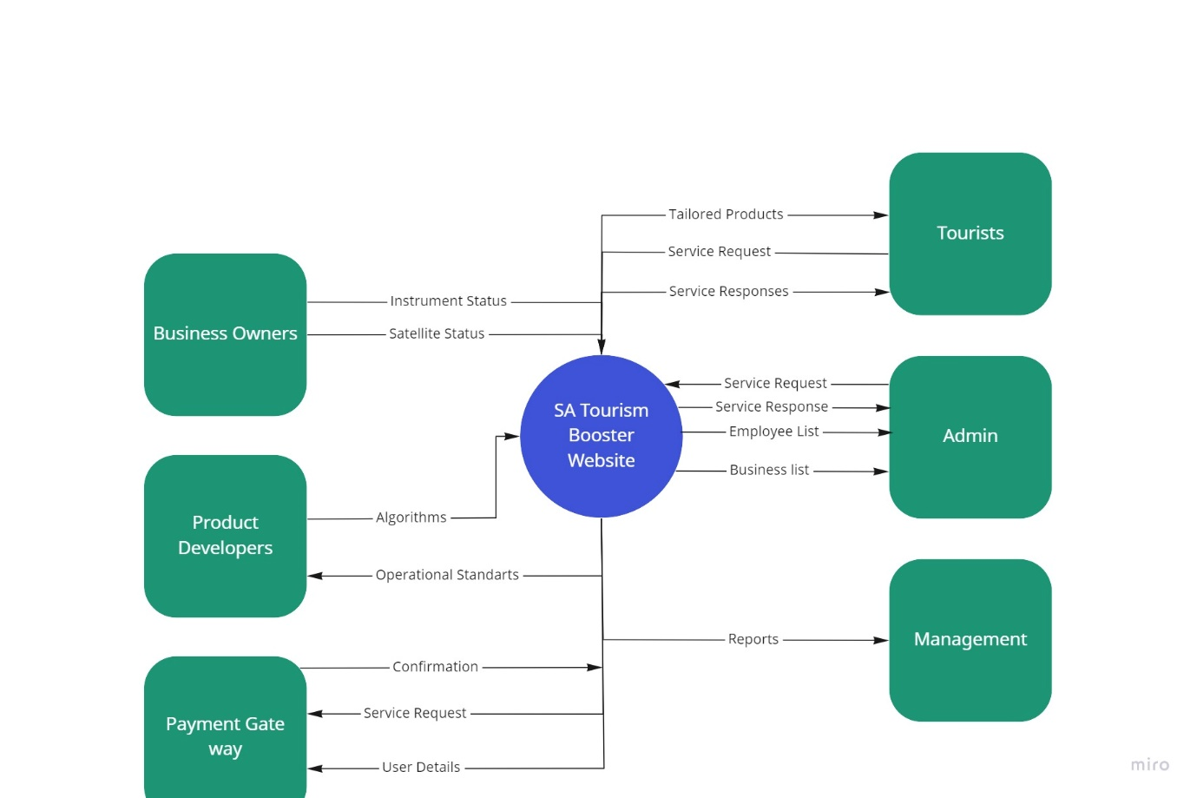

Figure 6 System Context Diagram

## 7.4 User Interface / Interaction Design

The goal of UX design is to customise every aspect of a user's interaction with a product. Additionally, interface design focuses on making sure users have a positive experience when using a product "at the time."

Initial User Flow:

Figure 7 Initial User Flow

Visual Designs:

Through the thoughtful use of graphics, colours, typefaces, and other aspects, visual design focuses on the aesthetics of a website and the materials that go with it. Successful visual design does not detract from the page's purpose or content.

Below are the screenshots of the visual design created for our website which shows how tourists, admin and business owner will interact with developed website.

Basic login webpages:

Registering as Business Owner by using below Screen:

Tourists can register to the website by using below register screen which is different when compared to business owner registration.

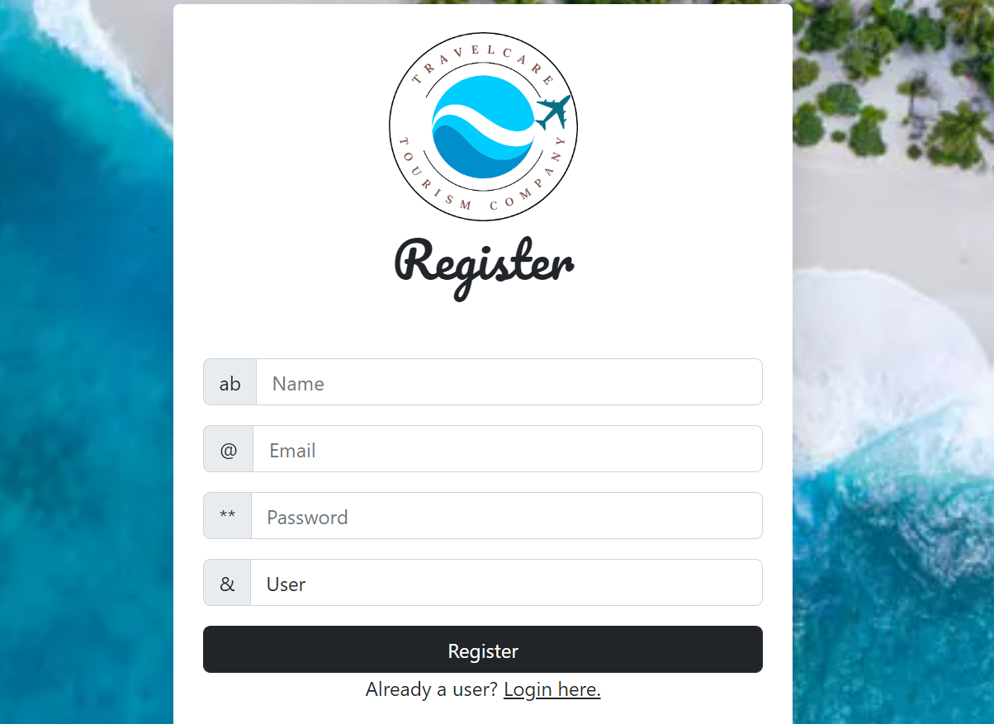

The home page design where website user will have information on the vision of the website and has About Us page to tell story to increase interaction.

Below is webpage that shows trending services to the website end users.

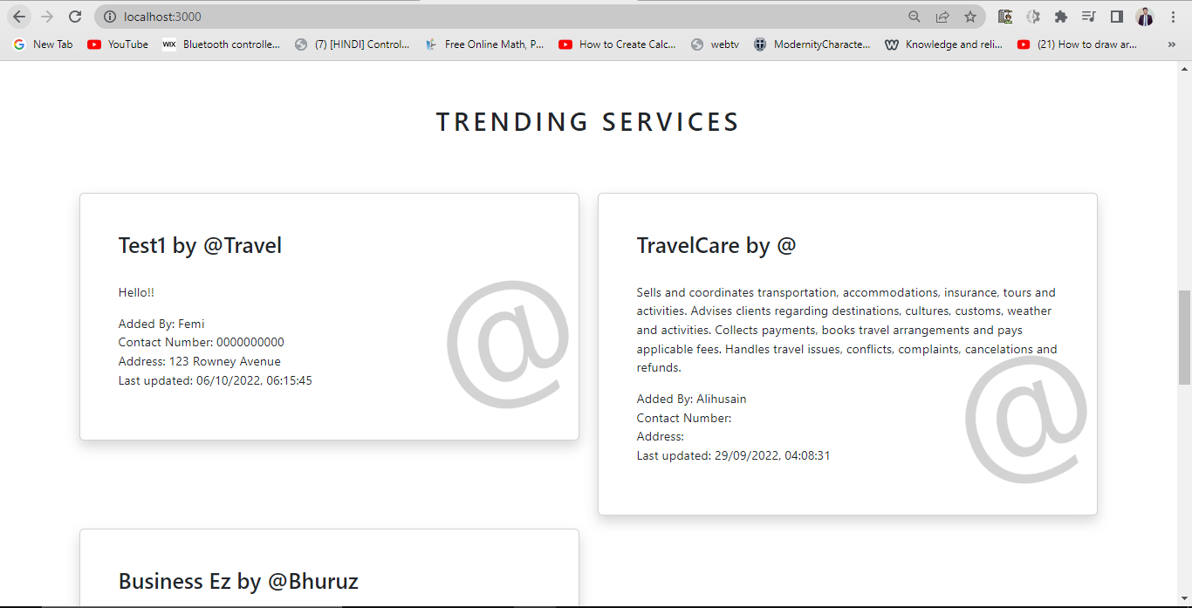

Below is Admin dashboard allowing Admin to manage users, that is admin from here is able to activate and deactivate web users including business owners and tourists.

Both Business Owners and Admin have access to business dashboard to add businesses/services. Also, can use action buttons to view, update or delete the services. The difference here is, Admin will be able to see all businesses listed while business owners will see only the businesses they have added.

The screen below is used by both tourists and business owners to add, view or update business.

Figure 8 SiteMap

## 7.5 Data model and software design

For storing the user’s data, we are going to use NoSQL database, which in particular is Mongo Db. The database will contain all the data and information, which will be used in the website. As this database, we do not have tabular form of data, rather it uses JSON array format. This would make sure that data is not redundant and easy to retrieve which will eventually increase the processing time.

Basic ER Diagram:

ER stands for Entity Relationship diagram, which shows the relationship of every entity, holds in the database. It gives the logical structure of database, which contains entities/class attributes and relationship between them.

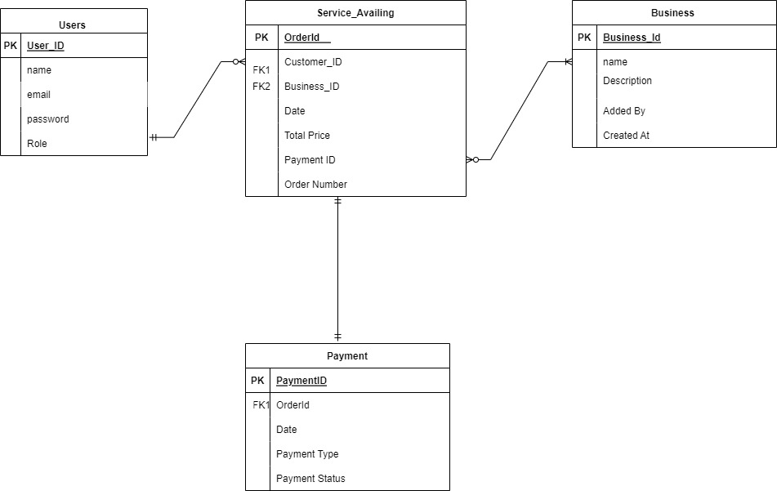

## 7.6 Assumptions

|  |  |
| --- | --- |
| No | Assumption |
| 1 | For the time being, the website is hosted on the localhost, whereas the server to be chosen to host is distributive, which means that approximated 500 users can access the website at the same time. |
| 2 | Any user can access the website at any time because it will be live on distributive server of Mongo Db |
| 3 | Internet should be available at all the times to access the website. |
| 4 | The minimum bandwidth to access the website very smoothly is 2Mb/s |
| 5 | For the required user’s requirement, the database of size 512 MB is enough to cater the users and business owner’s credentials and data. |
| 6 | The website is platform independent, however there must be a browser on that platform to access the website. |

## 7.7 External Dependencies

|  |  |
| --- | --- |
| No | Dependencies |
| 1 | The system is currently dependent on an external framework of JavaScript named as React as it utilizes the pre-coded CSS designs |
| 2 | Mongo DB server needs to be live, every time in order to let the users to access the website by providing their credentials. |
| 3 | Email verification is done using Heroku SMTP, so all the dependent libraries must be available all the times for Email verification and forgot password feature. |
| 4 | For encrypting the password, to enhance the security, services of B-crypt are used, so the architecture is also heavily dependent on it as well. |
| 5 | For user making payments via web interface need external third-party payment interface active and available whenever required. |

# Additional Components

*Include any other components here that you think are necessary, such as training plans, data conversion plans, maintenance plans, etc. Number each new section as above, starting at section 7*

# Index

*An index is optional. If you choose to include one, explore whether your word processor can do so semi-automatically for you.*

# Appendices

*Any supplemental items (such as change request forms, etc.) that do not form part of the handbook proper should be included as appendices.*